Manual GEWin-Excel
A tool to interpret VES

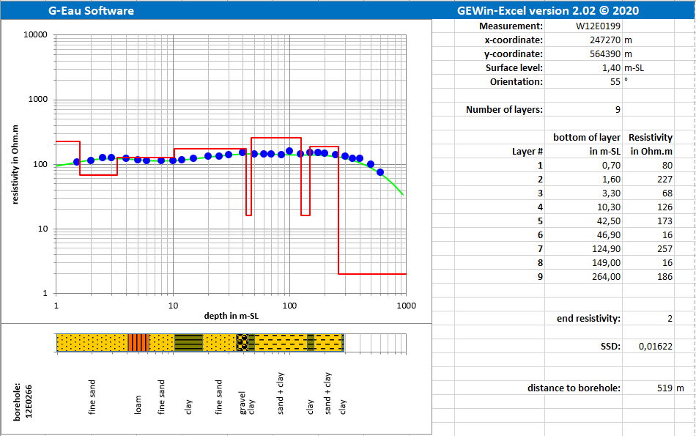

Ir. N.L. van der Moot,

Assen, March 2020

Contents
1. Introduction 1
1.1 About GEWin-Excel 1
1.2 Installation 1
1.3 Solving problems after installing GEWin-Excel 2
2. Getting started 3
2.1 Initializing a GEWin-Excel workbook 3
2.2 The “work” sheet 6
2.3 The structure of the GEWin-Excel workbook 8
3. Using GEWin-Excel 9
3.1 The “input GE-model” button 9
3.2 The “optimize GE-model” button 11
3.3 The “input field curve” button 13
3.4 The “ID-data model” button 15
3.5 The “modify borelog” button 16
3.6 The “load GEWin data” button 19
3.7 The “save GEWin data” button 21
3.8 The “remove items from GEWin database” button 23
3.9 The “assess formation resistivities based on EC-values and formation factors” button 25
3.10 The “GEWin-Excel workbook tools” button 29
3.11 The “undo” button 31
3.12 The “redo” button 31
3.13 The “remove GEWin toolbar” button 31
3.14 The “Version Info” button 32
4. The outline map 33
4.1 The “OutlineMap” sheet 33
4.2 Entering topographic background 34
4.3 Selecting via the interactive outline map 36
4.4 Zooming in 38
4.5 Zooming out 39
5. The X-section 40
5.1 Create a X-section 40
5.2 The “XSection” sheet 42

Introduction

About GEWin-Excel

GEWin-Excel Version 2.02 is an application to interpret geo-electrical measurements. GEWin-Excel is developed in Microsoft Office Excel 2007/2010. It is developed to be the successor of GEWin version 1.04 (January 2001) that operated under Windows95 and WindowsNT and version T22 that was developed for Office2003.
Since it is the successor of GEWin version 1.04 and GEWin-Excel version T22, it has all the functionalities of these previous versions and of course is upward compatible in the sense that the GEWin input files are also accepted by GEWin-Excel.
The first upgrading to an application in Microsoft Office Excel 2003 (version T22) has been used to add many helpful extras to make the interpretation and reinterpretation of measured resistivity curves more convenient.
Since 2020, GEWin-Excel is distributed as “G-Eau Software” (software of the consultancy agency: G-Eau Advies en Diensten) instead of “NiLe-Software”. This has led to a new, fresher look and some additions to the software. These extras will be explained in this manual.

Installation
First, it is important to make sure that a standard printer is selected that uses A4 paper, because the graph-sheets in GEWin-Excel are all designed for this format. If a standard printer is selected that uses another paper format (e.g. letter), GEWin-Excel will cause errors while initializing the GEWin-Excel-workbook.

GEWin-Excel is developed as an add-in for Microsoft Office Excel 2007 or later, so Microsoft Office Excel 2007 (or later) must be installed properly on your computer.
Beside the standard “Microsoft Office”-methods to install add-ins (refer to the Microsoft Office-manual), the “quick and easy”-method to install GEWin-Excel is:
1) Simply copy the add-in with the name “GEWin-Excel.xla” in a map on the computer (e.g. a map with the name “GEWin-Excel”).
2) Start Excel.
3) Go to the map with the add-in and double click on the add-in “GEWin-Excel.xla”.
The GEWin-Excel toolbar will appear in the ribbon under the tab “Add-ins” on top of the Excel-workbook.
So, the GEWin-Excel application is ready for use and can be used in any Excel-workbook.
If you do not remove the GEWin-Excel toolbar, the toolbar will remain in the ribbon under the “Add-ins” tab. If you did remove the toolbar by clicking on the “Remove GEWin toolbar”-button (see paragraph 2.1 and 3.13), you can simply re-activate the add-in by double clicking again on the “GEWin-Excel.xla”.

Be aware, that if you will (re)move or rename the map that contains the GEWin-Excel add-in, the GEWin-Excel toolbar will not be able to find the add-in anymore. So, if you want to (re)move or rename the map, first remove the GEWin-Excel toolbar (see paragraph 2.1 and 3.13)!!

Solving problems after installing GEWin-Excel

Forgetting to remove the GEWin-Excel toolbar:
In Excel it is only possible to remove installed “Add-ins” by software tools. So, before removing or replacing the add-in “GEWin-Excel.xla”, first click the “Remove GEWin-Excel toolbar”-button (see paragraph 3.13).
If you have forgotten to do this, the buttons have lost their connection with the software.
The only ways to remove the GEWin-Excel-toolbar are:
1) Place the add-in “GEWin-Excel.xla” again in the same place from where you have first loaded GEWin-Excel.
2) Run the macro in the also provided Excel-workbook “Remove GEWinExcel-toolbar.xlsx”. Simply open the workbook and click on the Hyperlinked button.

Problems with decimal separator:
Problems will occur while working with GEWin-Excel, if the settings of the decimal separator of Windows (country settings) are not matching the settings in Excel. Then decimal numbers will be text and error messages will occur.

Getting started

If the tab “Add-ins” in the ribbon on top of the Excel-workbook is not visible, first go to the “File”-tab. Click the “Excel options”-button, select the option “customize Ribbon” and then check the “Add-ins”-item. Immediately the “Add-ins”-tab with the GEWin-Excel toolbar will appear in your ribbon.

Initializing a GEWin-Excel workbook

After you have activated the GEWin-Excel toolbar (see above) the GEWin-Excel toolbar will appear in the ribbon-tab “Add-ins” (see figure 1).
While moving the mouse pointer over the buttons of the GEWin-Excel toolbar, a status bar will appear that indicates what the button is meant to do. The items in the toolbar can be activated as in each Windows-application by a single click with the mouse. In the following chapter the items of the toolbar will be discussed individually.

The GEWin-Excel workbook must be initialized by clicking on the “GEWin-Excel workbook tools” button. After clicking this button, a dialog form will appear that will offer you 5 options (see figure 2). When initializing a GEWin-Excel workbook, only the first 2 options are selectable.
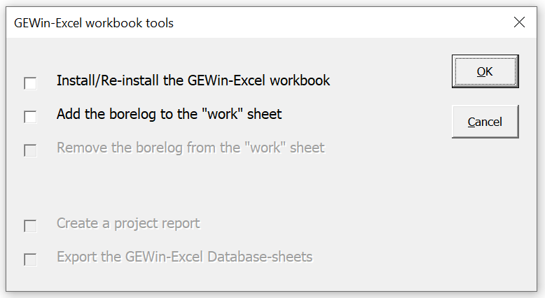
Figure 1

Mark the checkbox of the first option; “Install/Re-Install the GEWin-Excel workbook”.
Click the OK button.
Figure 2
input GE-model

modify borelog

GEWin-Excel workbook tools

load GEWin data

optimize GE-model

assess formation resistivities based on EC-values and formation factors

save GEWin data

input field curve

ID-data model

remove items from GEWin database

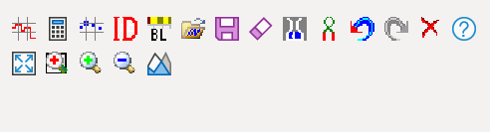
Zoom-out
undo changes

Set new focus for the outline map

Draw zoom-in area

Activate zoom-in

Define X-section

version info
remove GEWin toolbar

redo changes

GEWin-Excel will respond with the message that GEWin-Excel will initialize the workbook (see figure 3). Click the OK button.
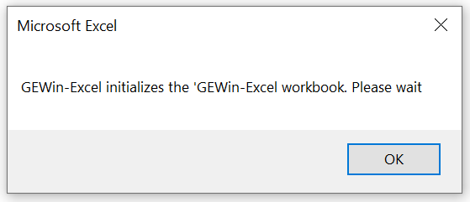
Figure 3
When you will initialize a GEWin-Excel workbook for the first time, the GEWin-Excel database is still empty, causing the standard message that GEWin-Excel has not been able to insert a sheet “OutlineMap” (see figure 4). Click the OK button.
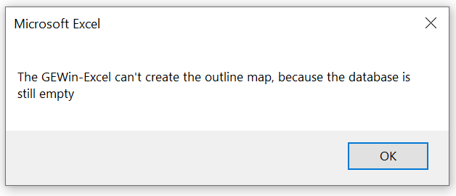
Figure 4

Once you have entered one or more measurements (and have saved them in the GEWin-Excel database!), GEWin-Excel will be able to create this outline map. So, just select the “GEWin-Excel workbook tools” button with the first option (Re-install the GEWin-Excel workbook) again.

The “work” sheet

When GEWin-Excel has finished initializing the workbook, the focus will be on the “work” sheet.
This “work”-sheet will look like the example of figure 5.
A prominent position on the “work”-sheet is reserved for the double logarithmic GEWin-graph. In this graph the field curves will be placed, together with the entered geo-electrical model (GE-model) and the calculated master curve for that model.
On the right-hand side of the GEWin-graph is a section reserved for presenting identification data on the field curve that will be interpreted and the geo-electrical model that has been entered.
In the ribbon-tab “Add-ins” on top of the Excel workbook you will find the GEWin-Excel toolbar (see figure 1 for a close-up). All communication with GEWin-Excel will run through this toolbar.
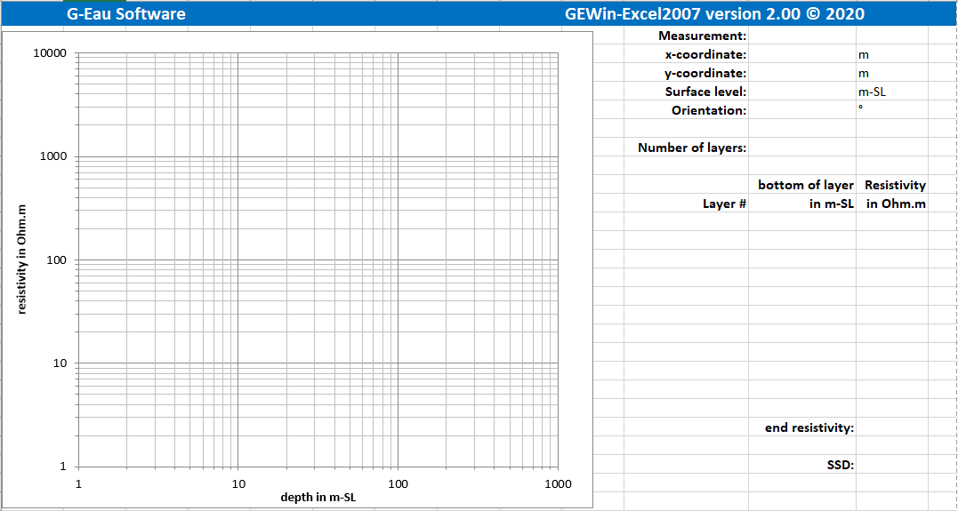
Figure 5

A feature of GEWin-Excel is that it is possible to add a borelog-graph to the “work”-sheet. The depth-scale of the borelog-graph is logarithmic and matches the depth-scale of the GEWin-graph. This feature can be helpful while interpreting a field curve, if a description of the soil units of a nearby borehole is available.
You can add this borelog graph, by clicking again on the “GEWin-Excel workbook tools” button (see paragraph 2.1). This time mark the second option in the dialog form that appears (see figure 2):
“Add the borelog to the “work” sheet”
Click the OK button.
Immediately the borelog graph will be placed under the GEWin-graph. At the same time the GEWin-graph will be resized (reduced height), so that both graphs will still fit on one A4-sized sheet of paper.
The “work”-sheet will now appear like the example of figure 6.
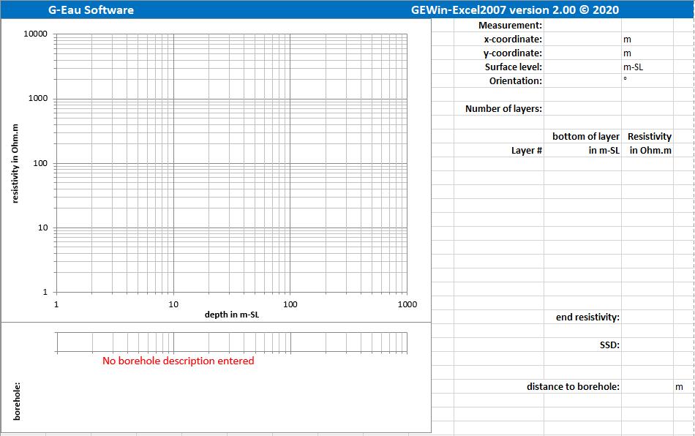
Figure 6

The structure of the GEWin-Excel workbook

When GEWin-Excel has finished initializing the workbook, you will see two sheets; the “work” sheet and the “input-curves” sheet.

The “input-curves” sheet is the only sheet in which you can make changes yourself. However, for a proper operation of the application it is strongly advised, only to make changes through the dialog forms that can be activated by the GEWin-Excel toolbar.
All other sheets are write-protected. The other (hidden) sheets are:
- the “DatabaseMeasurements” sheet
- the “DatabaseBoreholes” sheet
- the “Undo” sheet
- the “calculated curve” sheet
- the “DXF” sheet
These hidden sheets can be made visible by right clicking on any sheet name. Click the “Unhide” button. Now you will see a list with all hidden worksheets. Click on any worksheet name in that list and click the OK button. Hiding a worksheet again, works basically the same way; just click on “Hide” instead of “Unhide”.

Once you have saved measurements and boreholes to the GEWin-Excel database, you can also install a sheet “OutlineMap” (see paragraph 4.1). On this sheet will be an interactive outline map with the locations and names of the measurements and boreholes in the database. Through this interactive outline map, it is possible to define a trace for a cross section. Once you defined a cross section, a “XSection” sheet will be installed as well (see paragraph 5.2).

Using GEWin-Excel

All communication with GEWin-Excel will run through the toolbar, located in the “Add-ins” tab of the Excel ribbon (see figure 1 in paragraph 2.1). The toolbar contains 19 buttons. The function of the 14 buttons in the top row of the toolbar will be explained in the paragraphs of this chapter.

The “input GE-model” button

After selecting the “input GE-model” button, a dialog form will appear (see figure 7) through which the geo-electrical model (i.e. GE-model) for the subsoil can be entered. A maximum of 9 geo-electrical model layers can be entered.
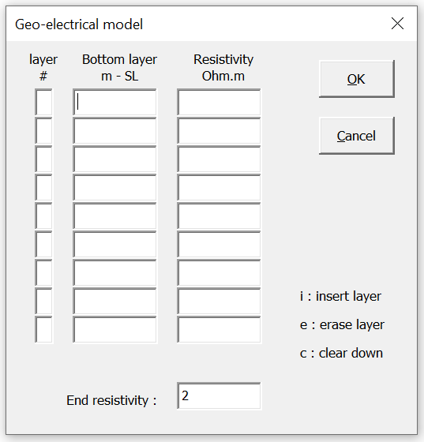
Figure 7

The bottom of each entered layer must of course be at a deeper level than the previous layer. The value of the resistivity should be more than 2Ωm and less than 10,000Ωm.
The value for the bottom of the (1st) layer should be larger than 0.1m.
If accidentally a shallower level is entered, or a value outside the set limits, you will be informed about this illegal entry after clicking the OK button. This message indicates at what location an illegal entry was made, to allow for a quick identification of the problem (see figure 8).

The end resistivity can be entered separately, in fact acting as a 10th layer of ‘infinite’ thickness.
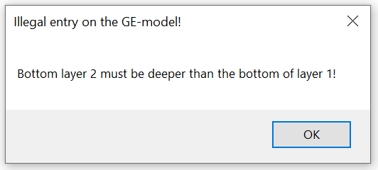
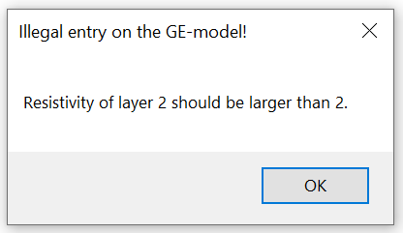
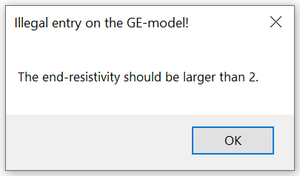
Figure 8: examples of error messages on the entry of a GE-model

In the first column (with the layer number), you can enter ‘i’ or ‘e’, if you want to insert or erase a layer respectively. If you enter ‘c’, all layers from that line on downward will be cleared (erased).
If you click the OK button, immediately the resistivity master curve, belonging to the entered geo-electrical model of the sub-soil, will be calculated.
If you click the CANCEL-button, you will leave the dialog form without changes.

The “optimize GE-model” button

The “optimize GE-model” button offers the facility to automatically optimize the entered geo-electrical model.
This option should only be used, after reaching an already good fit of the calculated resistivity master curve with the field curve by adjusting the parameter values manually. If the manually adjusted GE-model gives a good enough result, the optimization option can be used to finish off the process.

After clicking this button, a dialog form will appear on which three optimization parameters can be set (see figure 9):
- the termination criterion
- the search interval for the resistivity of the layers in %
- the search interval for the bottom of the layers in %

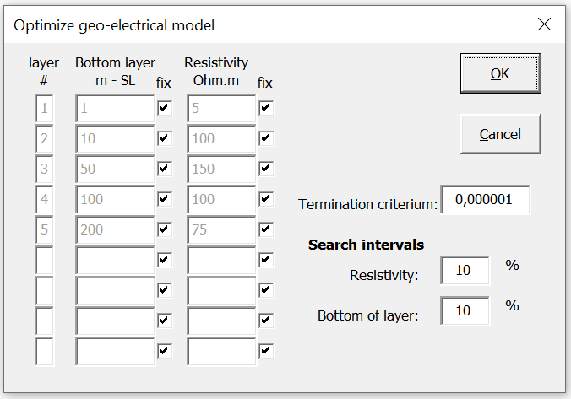
Figure 9

If the difference between the SSD-values (SSD=Sum of Squared Differences on a logarithmic scale) of 2 successive iterative optimization runs is less than the termination criterion, optimization will stop. The default is set at 0.000001.

The default value of the search intervals is set at 10%, both for the value for the level of the bottom of the layers as well as for the resistivity value of the layers.
During optimization the bottom of each layer as well as the resistivity of each layer is dealt with separately. Optimization starts with the bottom of layer 1. The SSD-value is calculated for the present level, the present level plus the search interval (default 10%) and the present level minus the search interval (default 10%). From these three results the best is selected and is used as the initial value for the next iteration step. Around this value a new search interval is created.
If the original value gave the best results, an interval is selected by taking the original value plus and minus half the previous interval.
If the original value plus the search interval gave the best results, this value will be the new search-interval centre. The new bottom-limit will be the original initial value, the new upper-limit the new search-interval canter plus the difference between this value and the new bottom-limit.
If the original value minus the search interval gave the best results, this value will be the new search-interval centre. The new upper-limit will be the original initial value, the new bottom-limit the new search-interval canter minus the difference between this value and the new upper-limit.
This process continues until the search interval narrows down to 0.
Next the same process starts for the bottom of the other layers in the interpretation.
After the bottom of the last layer has been optimized this way, the same process is used for optimizing the resistivity values of the layers. The SSD-value that is calculated after optimizing the resistivity value of the bottom layer equals the SSD-value of 1 iteration. If the difference between this value and the SSD-value of a previous iteration is less than the termination criterion, optimization is ready. Otherwise the process starts all over again.

Initially all the parameters of the GE-model are fixed; this means NOT free for automatic optimization. The parameter that must be optimized has to be released by unmarking the checkbox behind the parameter in the column “Fix”.

Usually the default values of the 3 parameters governing the optimization process, do not need to be changed.
Leaving the menu by clicking the Cancel-button will result in no optimization and ignoring the changes made since entering the menu.
By clicking the OK-button, optimization will start. GEWin-Excel will keep you updated with the optimization process by the “Status bar” at the bottom of the GEWin-Excel-workbook. The “Status bar” indicates in which optimization loop the process is.

The “input field curve” button

After clicking the “input field curve” button a dialog form will appear (see figure 10) that will facilitate a field curve to be entered manually, or to modify a field curve that has been imported, or has been loaded from the GEWin-Excel database.
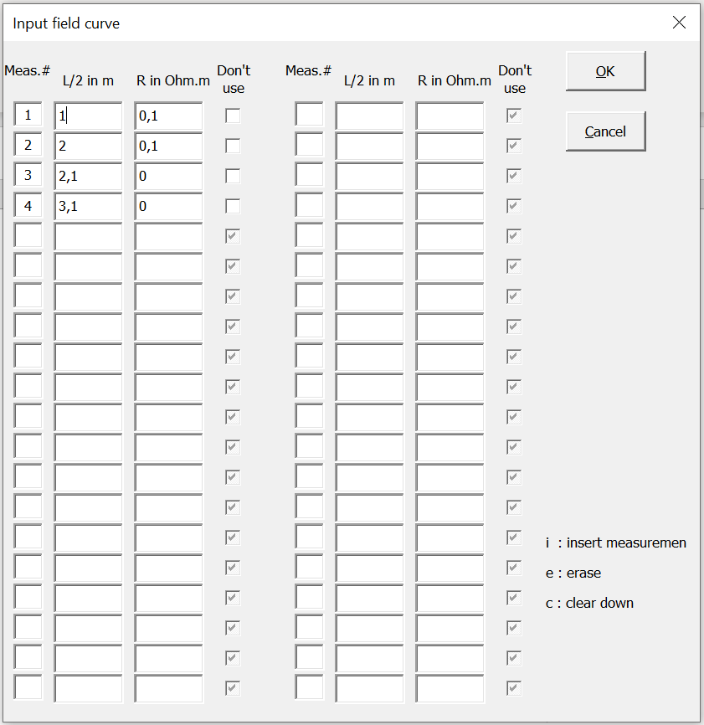
Figure 10

An empty sheet has some default values (see figure 10). Simply overwrite these values.
The field readings (combination of L/2 in m and R in Ohm.m) must be entered in the order of increasing distance of the electrical current electrodes. If accidentally a decreasing distance is entered, you will be informed about this illegal entry after clicking the OK button. This message indicates at what location an illegal entry (entered pair of values) was made, to allow for a quick identification of the problem (see figure 11).

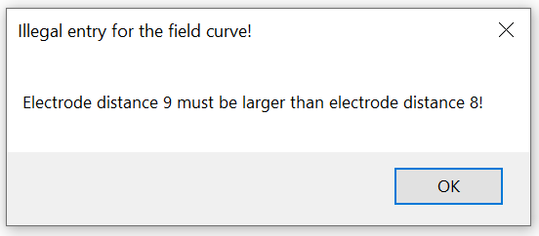
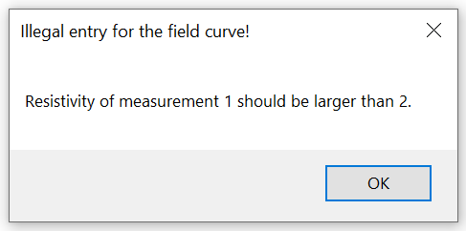
Figure 11: examples of error messages on the entry of a field curve

When the potential electrodes are replaced during the measurement, two resistivity values are obtained for the same spacing of the two electrical current electrodes. When entering both values, the program will calculate a "shifted" resistivity value. Later, only the "shifted" resistivity values will be used and saved by GEWin-Excel.

Behind each data-pair, a checkbox is available. If you mark this checkbox, the data-pair will not be used for the calculation of the Sum of Squared Differences (SSD). This also means that this data-pair will not be used during the automatic optimization of the entered GE-model. This can be helpful if a reading is obviously out of range, e.g. because the measurement crossed an iron pipeline. On the graph the marked data-pair will appear as an open dot in the graph, where the unmarked data-pairs are plotted as filled dots.

In the first column (with the number of the data-pair), you can enter ‘i’ or ‘e’, if you want to insert or erase a data-pair respectively. If you enter ‘c’, all data-pairs from that line on downward will be cleared (erased).
If you click the CANCEL-button, you will leave this screen without changes.

The “ID-data model” button

After clicking the “ID-data model” button a dialog form will appear (see figure 12) that will facilitate entering identification data (i.e. ID-data) for the combination GE-model/field curve.

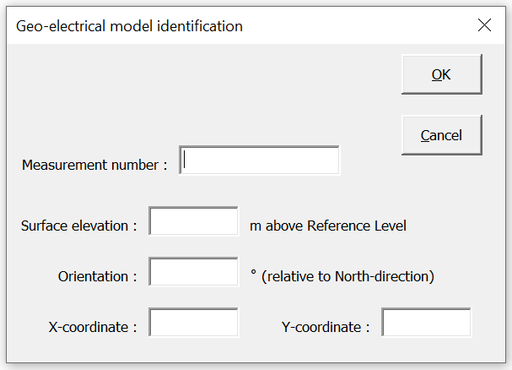
Figure 12

Besides the number of the measurement, three other characteristics of the GE-model/field curve can be entered:
- the surface elevation of the location of the field curve
- the orientation of the field curve, relative to the North direction
- the x- and y coordinates of the location of the field curve.
The orientation of the field curve is a new ID-item, as compared to GEWin version 1.04.
The ID-data you entered will be printed on the datasheet on the right-hand side of the double logarithmic GEWin-graph in the “work”-sheet.
If you click the CANCEL-button, you will leave this screen without changes.

The “modify borelog” button

A new feature of GEWin-Excel, as compared to GEWin version 1.04, is the possibility of adding a borelog-graph to the “work”-sheet. The depth-scale of this borelog-graph is logarithmic and matches the depth-scale of the GEWin-graph. This feature can be helpful while interpreting a field curve, if a description of the soil units of a nearby borehole is available. After processing the information of the borelog, the “log”-grouped soil units (i.e. the soil units have been combined to bigger units that are still significant to the logarithmic scale of the depth interval of the units) can be placed in the borelog-graph.
After clicking the “modify borelog” button a dialog form will appear (see figure 13) that will facilitate entering the “log”-grouped soil units.

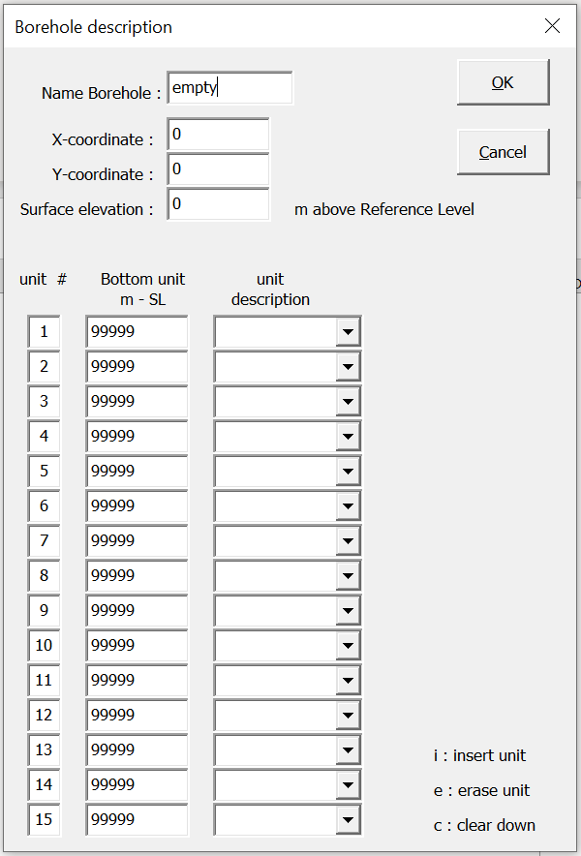
Figure 13

Entering the identification data at the top of the dialog is required. If these fields remain empty an error will occur (see figure 14).
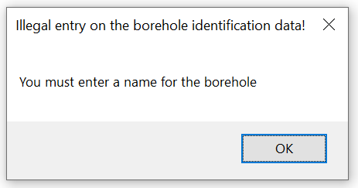
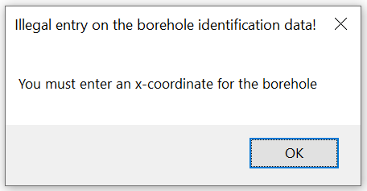
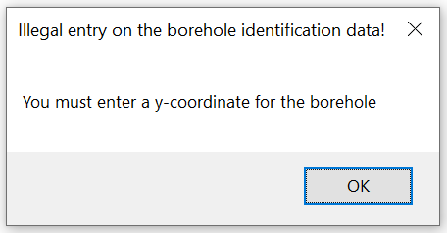
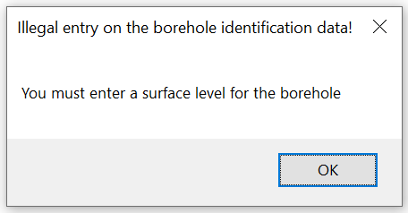
Figure 14: examples of error messages on the identification data of a borehole

The bottom of each entered soil unit must be at a deeper level than the previous soil unit. The value for the bottom of the (1st) soil unit should be larger than 1m-SL to fit on the graph.
If accidentally a shallower level for the first soil unit is entered, or a depth that is shallower than the depth of the previous soil unit, you will be informed about this illegal entry after clicking the OK button. This message indicates at what location an illegal entry (number of entered layer) was made, to allow for a quick identification of the problem (see figure 15).

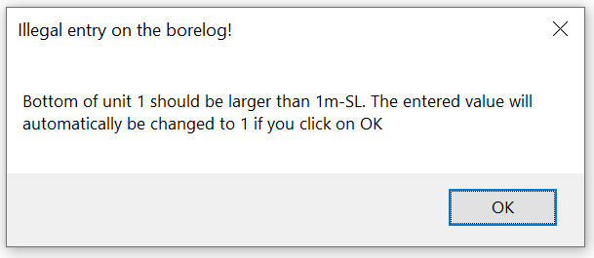
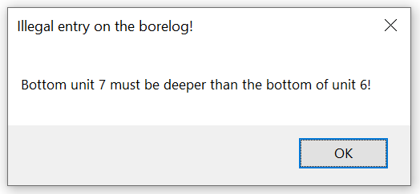
Figure 15: examples of error messages on the entry of a borelog

In GEWin-Excel a total of 17 different soil units are available to be plotted in the borelog-graph. These soil units can be selected by the drop-down boxes in the column “unit description” on the dialog form. The available soil units are:
- peat
- loam
- clay
- sandy clay
- sand + clay (until version 1.05: fine sand + clay)
- silty/clayey sand
- very fine sand
- fine sand
- coarse sand
- gravel
- limestone
- sandstone
- shale
- intrinsic rock
- volcanic rock
- metamorphic rock
- other
If you start typing in the entry box for the “unit description”, GEWin-Excel will give as suggestion the first standard soil unit available beginning with the entered string. So, if you type “c” the first suggestion will be “clay”. If continue typing “co” the suggestion will change to “coarse sand”. This option may speed up entering a borelog.
Each soil unit will be presented in the borelog-graph with a characteristic pattern of the unit. Besides, the soil unit will be presented in text as well. The text is placed halfway the depth interval of the soil unit, under the borelog-graph.
It is possible to enter any other unit description. However, soil descriptions that differ from the exact descriptions in the drop-down boxes will be plotted (just like the soil unit “other”) all in white background colour with a black large grid.
If you click the CANCEL-button, you will leave this screen without changes.

If the last soil unit is part of the geohydrological base (which often is close to the geo-electrical base) it is possible to visualize this by extending the soil unit till a depth of 1000m-SL (i.e. the maximum depth scale of the “Borelog” graph). This will not affect the construction of the cross section (see chapter 5).

The “load GEWin data” button

After clicking the “load GEWin data” button a dialog form will appear (see figure 16) that will facilitate entering GEWin data.
In GEWin-Excel, GEWin data can be entered in two different ways; by importing a datafile, or by loading GEWin data from the GEWin database. GEWin-Excel facilitates importing 2 different file formats; TNO VES-data files and GEWin version 1.04 data files.
Select either option by marking the checkbox in front of the option (or by clicking on the text of the option itself). By default, the option to load data from the GEWin-Database is marked.
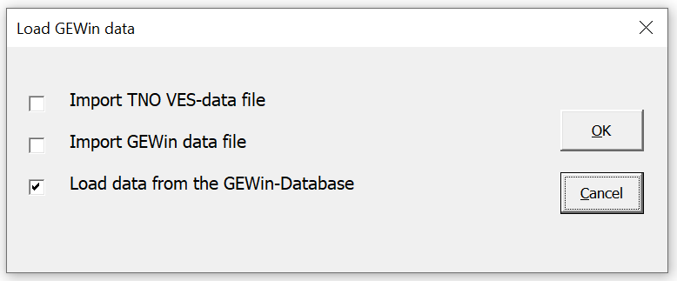
Figure 16

After selecting “Import TNO VES-data file” and clicking the OK-button, a standard Windows file manager will appear, that facilitates finding the input files within the available maps. The same accounts for importing GEWin data files.
If you click the CANCEL-button, you will leave this screen without changes.

After selecting “Load data from the GEWin-Database” and clicking the OK-button, the next dialog form will appear (see figure 17-top).

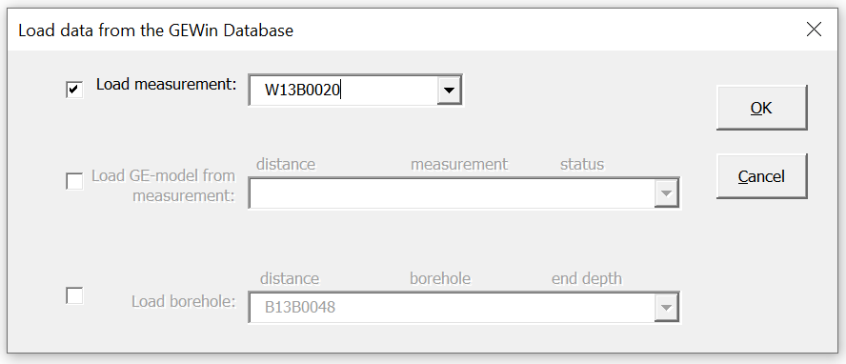
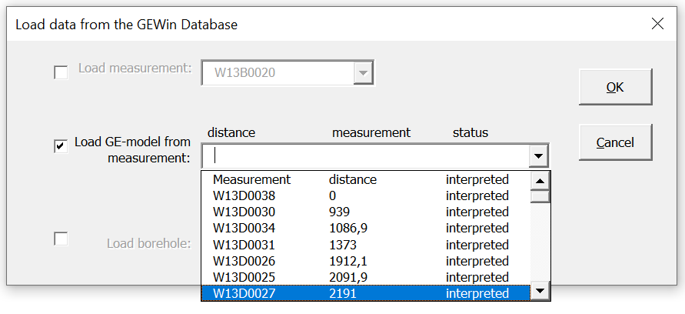
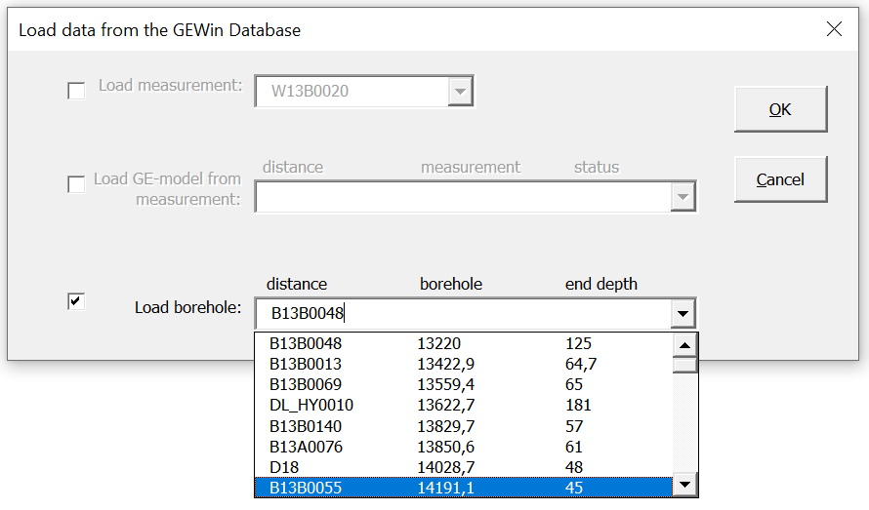
Figure 17

Through this dialog form it is possible to load:
• a geo-electrical measurement
• the GE-model from an already interpreted measurement nearby
• a borelog from the GEWin-Database.
By default, the option for loading a geo-electrical measurement is selected, while the options for loading a GE-model and loading a borelog are made inactive. It is possible to toggle between the three options, by clicking on the checkbox in front of the option.
If you want to load a measurement, all the measurements in the GEWin-Database will be ordered in alphabetical and numerical order. You will enter the GEWin-Database at the location of the measurement that is presently loaded in GEWin-Excel. By typing in the “input” frame it is possible to move fast through the GEWin-Database towards the measurement that you want to select. Be aware that the GEWin-Database is capital sensitive.
If you want to load an GE-model from an already interpreted measurement, the measurements will be ordered in increasing distance to the measurement you are currently interpreting. In the drop-down box, you will first find the name of the measurement, followed by the distance to the measurement you are currently interpreting and finally information whether the measurement has been interpreted or not (see figure 17-middle).
Also, if you want to load a borehole to place in the borelog-graph underneath the GEWin-graph, the boreholes will be ordered in increasing distance to the measurement you are currently interpreting. In the drop-down box, you will first find the name of the borehole, followed by the distance to the measurement you are currently interpreting and finally the depth of the borehole (see figure 17-bottom). If only basic information (name of the borehole, x- and y-coordinate, surface level) has been entered, but no soil units, the depth is presented as “unknown”.
If you click the CANCEL-button, you will leave this screen without changes.

The “save GEWin data” button

After clicking the “save GEWin data” button the present GE-model, together with ID-data, the field curve and if applicable the used borelog will be saved in the GEWin-Database. If the geo-electrical measurement is already in the GEWin-Database, GEWin-Excel will ask you if you want the records in the GEWin-Database to be overwritten by the new data (see figure 18).

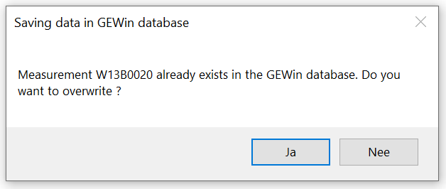
Figure 18

If you will click the “Yes” button, the record will be overwritten.
If you will click the “No” button, GEWin-Excel will ask you (see figure 19) to either change the name of the measurement (click the “OK” button), or to cancel saving the data of the geo-electrical measurement (click the “Cancel” button). If you select “OK” you will be asked to save the same measurement under another (unique) name. This way it is possible to save 2 or more alternative interpretations. It means that at the same location (x, y-coordinate) two measurements are saved.
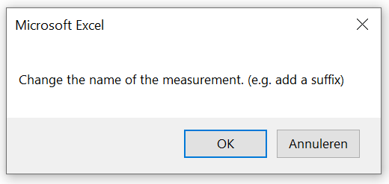
Figure 19

If applicable, GEWin-Excel will check next if the borelog is already in the GEWin-Database. In case it is, GEWin-Excel will ask you if you want the records in the GEWin-Database to be overwritten by the new data (see figure 20).
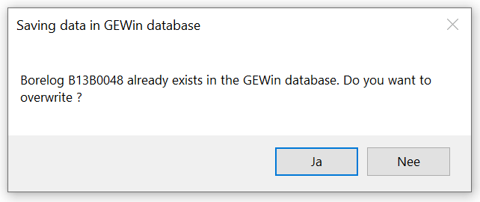
Figure 20

If you will click the “Yes” button, the record will be overwritten.
If you will click the “No” button, GEWin-Excel will ask you (see figure 21) to either change the name of the borelog (click the “OK” button), or to cancel saving the (changed) data of the borelog (click the “Cancel” button).

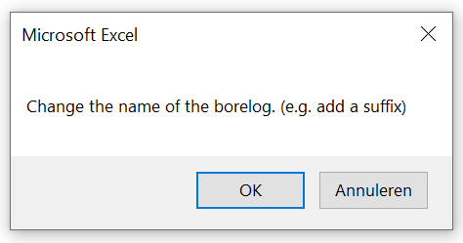
Figure 21

The “remove items from GEWin database” button

After clicking the “remove items from GEWin database” button a dialog form will appear (see figure 22) that will facilitate removing junk records from the GEWin-Database.
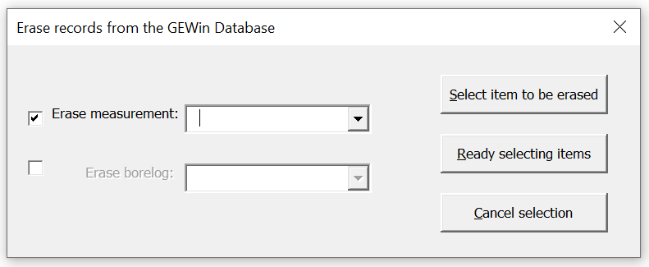
Figure 22

Through this dialog form it is possible to select geo-electrical measurements and/or borelogs from the GEWin-Database to be removed. By default, the option for selecting geo-electrical measurements is selected, while the option for selecting borelogs is made inactive. It is possible to toggle between both options, by clicking on the checkbox in front of the option.
The items in the GEWin-Database are always ordered in alphabetical and numerical order. By typing in the “input” frame it is possible to move fast through the GEWin-Database towards the measurement that you want to select. Be aware that the GEWin-Database is capital sensitive.
First find the measurement that you want to remove. Next click the button “select item to be erased”. Next you select more measurements to erased and repeat the procedure. If you want borelogs to be removed as well, first mark the checkbox in front of this option and continue the procedure. It is no problem, if you accidentally clicked more than once on the same item.
After you selected all the measurements and borelogs that you want to remove from the GEWin-Database, click the button “Ready selecting items”.
Next you will be asked by GEWin-Excel, whether you are sure that you want the selected items to be erased from the GEWin-Database (see figure 23).
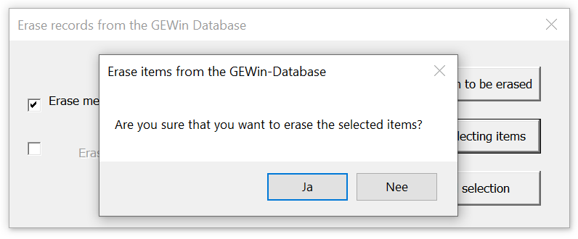
Figure 23

If you click the “Yes” button, the items will be erased. Clicking the “No” button will leave the GEWin-Database unchanged.

If you have selected borelogs to be erased from the GEWin-Database, that are still linked to one or more geo-electrical measurements that are not erased, GEWin-Excel will not be able to erase the borelog immediately. First GEWin-Excel will ask you if you want to remove the links to the geo-electrical measurements (see figure 24).
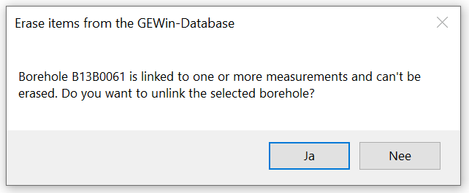
Figure 24

If you click the “Yes” button, the links will be removed from the GEWin-Database and next the borelog will be erased from the GEWin-Database.
If you will click the “No” button, the links will remain in the GEWin-Database and so will the borelog.

If you have accidentally erased items from the GEWin-Database, and you have not yet clicked on either the Excel-button “Save” or the button “Save GEWin data”, then it is still possible to undo the erasing. Just exit the GEWin-Excel workbook without saving. Next just reopen the GEWin-Excel workbook.

The “assess formation resistivities based on EC-values and formation factors” button

For the hydrogeological interpretation of geo-electrical measurements, you will need to calibrate the (formation) resistivities of the layers that have been distinguished. If in the vicinity of the geo-electrical measurement a geophysical log is available, you can use the (formation) resistivities indicated on the log for the different layers. However, geophysical logging data are usually scarce.

Another possibility is using the EC-values (i.e. the values of the Electric Conductivity) of the formation water, as measured in groundwater samples, taken from observation wells. In many places these data are more abundantly available. If these data are available, the option behind the button “assess formation resistivities based on EC-values and formation factors” offers you a facility, to calculate the formation resistivity of a layer, based on the EC-value of the groundwater in this layer. After clicking on the button, a dialog form will appear (see figure 25) in which you can change the presented default values for the EC of the formation water (in µS/cm) as determined at a temperature of 20°C and the temperature of the formation water (in °C) respectively.
Once you changed either the EC-value of the groundwater sample or the temperature of the formation water, the formation resistivities will be blanked. After clicking the button “Calculate” the formation resistivities will be calculated for the new combination of EC-value and temperature.
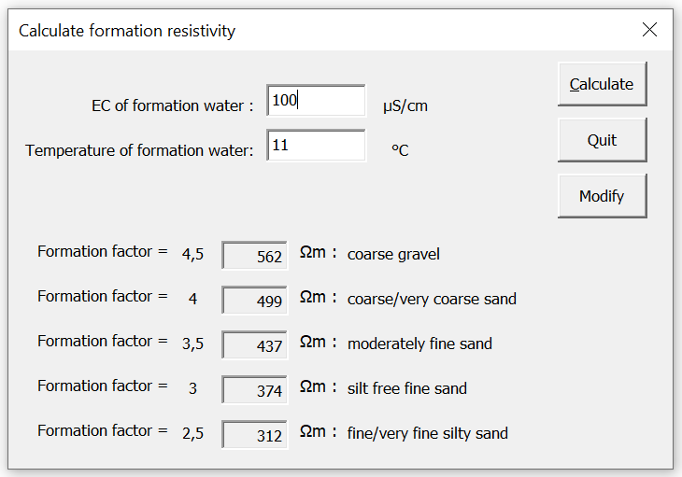
Figure 25

The formation resistivity is calculated as follows:

ρ_{f} = ρ_{p} x F/d²

with:
ρ_{f} : specific electrical formation (or soil) resistivity in [Ωm];
ρ_{p} : specific electrical resistivity of the pore liquid in [Ωm];
F : formation factor (dimensionless);
d : saturation factor of the pores (dimensionless);

The electrical conductivity is temperature dependent and is usually determined for a temperature of 20°C with the current brands of EC meters. The temperature of the pore water may be different. In the Netherlands, the average temperature of the water in shallow aquifers is about 11°C.

For the conversion, the following formula is used:

EC_{temp} = EC₂₀ / f

with:

EC_{temp} : electrical conductivity of the formation water at the temperature of the formation (e.g. 11°C);
EC₂₀ : electrical conductivity as determined at 20°C;
f : temperature coefficient of the specific resistivities of the electrolytes;

The temperature coefficient is represented by:

f = -0.420479 * ln( T ) + 2.25807

with:

T: the temperature of the formation water in °C

The subsequent recalculation from EC-values in μS/cm to pore water (pore liquid) values in Ωm is carried out as follows:
ρ_{p} = 10,000/EC

The results of this calculation are presented for 5 different formation factors (in default varying from 2.5 to 4.5 at an interval of 0.5). They are specified for a saturated subsoil (i.e. d = 1). For each formation factor a default description is given of the texture of the sediment being representative for average Dutch field conditions. It is possible to modify both the default formation factors and the default descriptions of the texture of the sediment.

After clicking the “Modify” button the appearance of the dialog form will change (see figure 26).
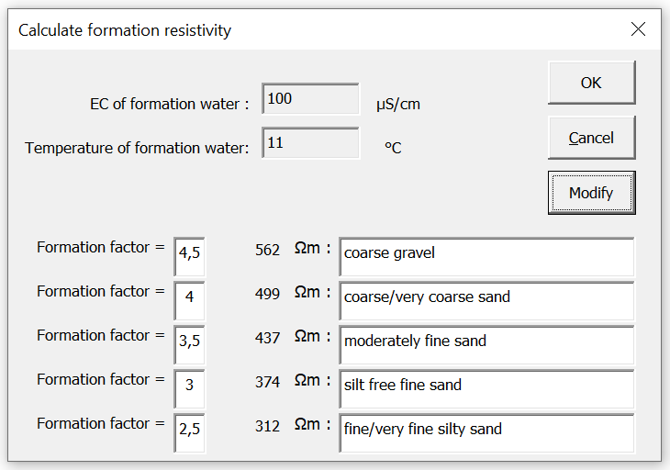
Figure 26

The only difference is that the edit-boxes for entering both temperature and the EC-value of the water are inactive, while both the formation factors and the sediment descriptions are now presented in active edit-boxes. Five formation factors can be entered, representative for the field where the interpreter is working. The entered values should be less than 100 and can have 1 decimal (i.e. a maximum value of 99.9).
Sediment descriptions can be entered in any language. The only restriction is that the description should not exceed 30 characters.
After clicking the “OK” button, the changes will be effective, and you will return to status of the dialog form in which you assess the formation resistivities.
After clicking the “Cancel” button, the made changes will be undone and you will return to status of the dialog form in which you assess the formation resistivities.

The entered descriptions will be saved in GEWin-Excel as soon as you have clicked the Excel button “Save”.

The “GEWin-Excel workbook tools” button

After clicking the “GEWin-Excel workbook tools” button a dialog form will appear that will offer you 5 options (see figure 27).
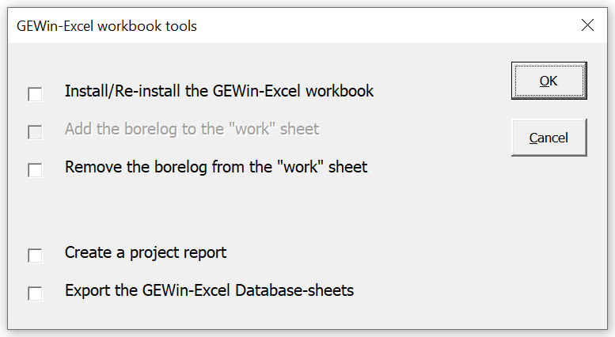
Figure 27

If anything went wrong with the GEWin-Excel workbook, the first option will re-install the GEWin-Excel workbook. First make sure that you have deleted all corrupted sheets. Usually these are the “work” sheet and the “OutlineMap”-sheet. Be aware that there are several hidden sheets as well.
With the first option, it is also possible to create a new GEWin-Excel workbook (see paragraph 2.1).

The second and third option are excluding each other. Therefore, it is not possible to select them both at the same time. If you select the option “Add the borelog to the “work” sheet”, the borelog-graph will be placed on the “work” sheet, underneath the GEWin-graph. At the same time the GEWin-graph will be resized (reduced height), so that both graphs will still fit on one A4-sized sheet of paper (see paragraph 2.2).
After selecting the option “Remove the borelog from the “work” sheet”, the borelog-graph will be removed from the “work” sheet. At the same time the GEWin-graph will be resized (increased height), so that the graph will optimally fit on one A4-sized sheet of paper.
Of course, selecting the option to add a borelog, while a borelog is already present (or remove a borelog while there is no borelog) will result in no changes to the “work” sheet.

When you will install the GEWin-Excel workbook, the GEWin-Excel database is (still) empty. This results in a message that GEWin-Excel has not been able to insert a sheet “OutlineMap” (see figure 4 in paragraph 2.1).
The last two options (“Create a project report” and “Export the GEWin-Excel Database sheets”) are only available when you have saved at least 1 geo-electrical measurement in the GEWin-Excel database.

Create a project report
If you select the option “Create a project report” GEWin-Excel will add 2 extra sheets to the GEWin-Excel workbook.
In the first sheet you will give you (see figure 28):
1st column: an overview of all the measurements in the GEWin-Excel database,
2nd column: for each measurement the SSD (second column) as an indication of the quality of the geo-electrical model,
3rd column: for each measurement the number of discarded field values as an indication of the quality of the field curves.

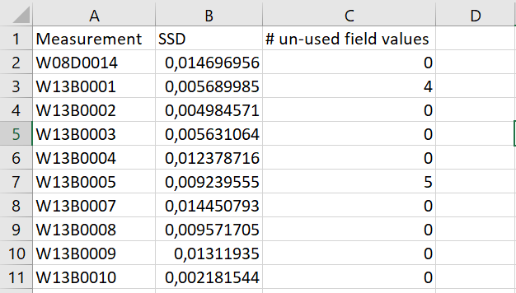
Figure 28

The second sheet will contain the “work”-sheets of all the measurements in the GEWin-Excel database with the interpretation (GE-model). They are placed in this sheet in groups of 4 prints in a way that they will fit exactly on an A4-form when printed.

Export the GEWin-Excel Database sheets
Selecting the option “Export the GEWin-Excel Database sheets” will result in copying the 2 database sheets to a new Excel-workbook, together with the DXF sheets with topographical features for the outline map. This gives the opportunity to save a project in a compressed way.

The “undo” button

With the “undo” button changes made in the GE-model, the field curve, the ID-data, or the borelog can be undone. You can undo changes until you load a new measurement. Also, after closing GEWin-Excel and resuming work the next day, the previous changes can still be undone.
When you move with the mouse pointer over the “undo” button a status bar will appear that indicates the undo action that will follow a next click on the button. If there are no “undo” possibilities left, the button will turn inactive and the status bar will show the text “empty”.

The “redo” button

With the “redo” button changes that have been recently undone can be redone again. You can redo changes until you have made a new change to a GE-model, a field curve, ID-data or a borelog. Also, after closing GEWin-Excel and resuming work the next day, the previous changes that have been undone can still be redone.
When you move with the mouse pointer over the “redo” button a status bar will appear that indicates the redo action that will follow a next click on the button. If there are no “redo” possibilities left, the button will turn inactive and the status bar will show the text “empty”.

The “remove GEWin toolbar” button

With the “remove GEWin toolbar” button you can remove the toolbar before closing the GEWin-Excel workbook. This way you won’t have the GEWin-toolbar always visible if you are working with Excel, but not with GEWin-Excel.
The GEWin-Excel toolbar will automatically reappear when you will restart GEWin-Excel.
If you have clicked on the “remove GEWin toolbar” button, but want to resume work, you will have to close GEWin-Excel first and then restart.

The “Version Info” button

With the “Version Info” button you can find information about the currently installed version of GEWin-Excel (see figure 29).
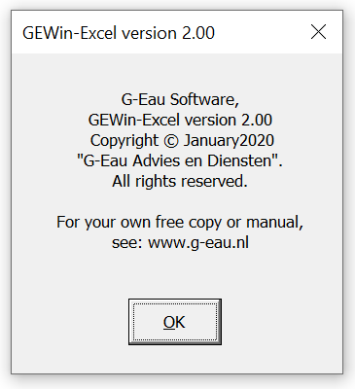
Figure 29

The outline map

The “OutlineMap” sheet

Once you have entered one or more measurements and one or more boreholes to the GEWin-Excel database, GEWin-Excel will be able to create an interactive outline map.
This interactive outline map will be created on a new sheet with the name “OutlineMap”. This sheet will be added by selecting the “GEWin-Excel workbook tools” button with the first option (Install/Re-install the GEWin-Excel workbook).
You may move to the outline map by clicking on the sheet-tab with the name “OutlineMap”.
The first time the outline map is installed, the focus of the map will be set to such limits that all the measurements in the database will be visible on the map (see figure 30).
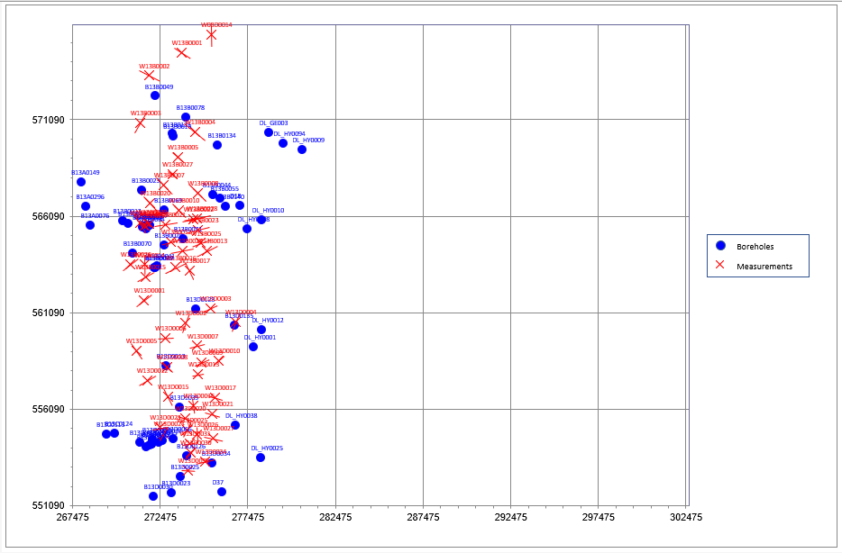
Figure 30

The boreholes are presented on the map with blue filled dots. The geo-electrical measurements are presented on the map with red lines. These lines have the length and the orientation of the measurements. The name of the measurement will be printed in red above the centre point (red cross) of the line of the measurement.

Entering topographic background

Topographic features can be added to the outline map, to help orientation on the map.
If you want to present some topographical features on the outline map, you can add them manually.
First you will have to unhide the DXF-sheet (see paragraph 2.3).
Next you can enter the coordinate pairs to define the lines that form the topographic features; the x-coordinates are in the first column (“A”) and the y-coordinates in the second column (“B”). A line can consist of a large series of coordinate pairs. Once a new line starts, there should first be two empty cells. Each set of columns can reach a maximum length of 31000 rows long. After that a new series of columns should be started, separated from the first set of columns by two empty columns (see figure 31).
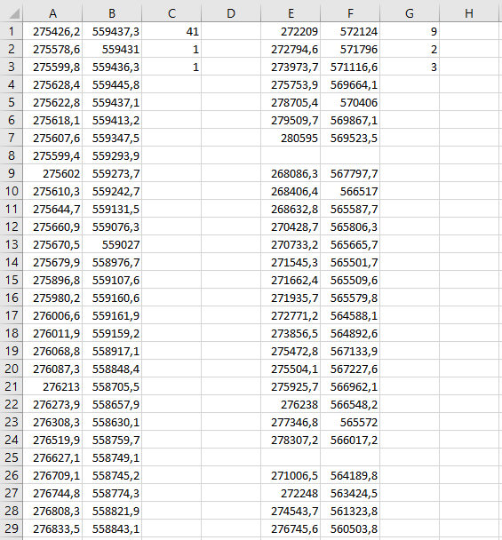
Column that contains information of how to draw the topographic lines:
1st line: color
2nd line: width
3rd line: line style
One empty column to separate series of topographic lines
Two empty cells to separate two topographic lines
Figure 31

The appearance of all the topographic features defined in columns A-B is set by the first 3 values of column “C”: first a number indicating the colour (refer to figure 33), then a value for the width of the line and finally a number indicating the style of the line (refer to table 1). In a similar way all the topographic features defined in columns E-F are defined by the first 3 values in column “G”, and so on. If no values are entered in these columns “C”, “G” and so on, GEWin-Excel will set default values (37, 2 and 1), representing light blue solid lines (see figure 32).
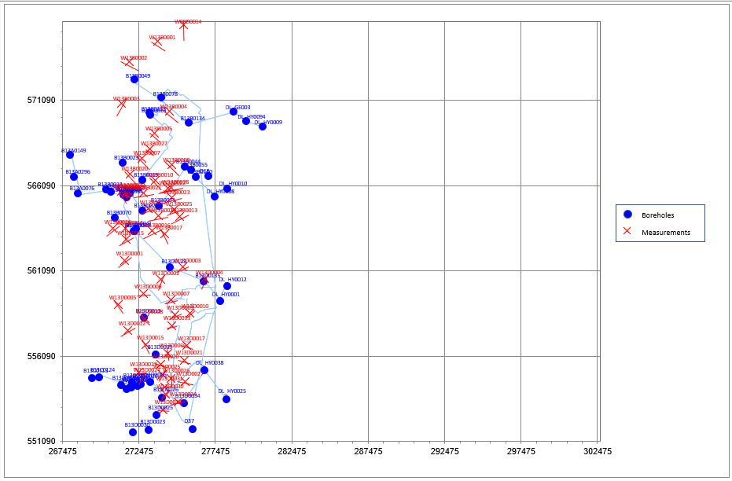
Figure 32

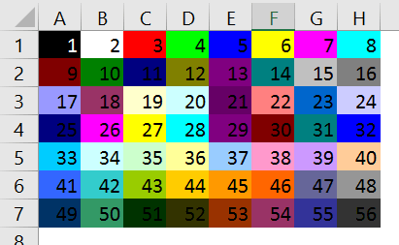
Figure 33

Table 1: line style code for topographic features

Value | Description
1 | Line is solid.
2 | Line is made up of square dots.
3 | Line is made up of round dots.
4 | Line consists of dashes only.
5 | Line is a dash-dot pattern.
6 | Line is a dash-dot-dot pattern.
7 | Line consists of long dashes.
8 | Line is a long dash-dot pattern.

Selecting via the interactive outline map

The names of both the boreholes and measurements are hyperlinked. When you move the mouse indicator over the map, the mouse indicator will change to a hand followed by a textbox with the name of the borehole or measurement, while shifting into the active field around the name.
After clicking in the active field around the name of the measurement, the measurement will be loaded in GEWin-Excel. The focus will move immediately to the “work” sheet.
After clicking in the active field of the name of a borehole, the borelog will replace the borelog in the “Borelog” graph on the “work” sheet (or just placed in the “Borelog” graph if it was still empty).
If a measurement has been saved in the GEWin-Excel database with alternative GE-models (se paragraph 3.7), GEWin-Excel will find back all the alternatives in the database. After finding the alternatives, a dialog will appear that tells how many alternatives have been found and it will allow you to select the desired alternative (see figure 34). After selecting the desired alternative and clicking on the OK-button, the alternative will be loaded in GEWin-Excel after which the focus will immediately move to the “work” sheet.
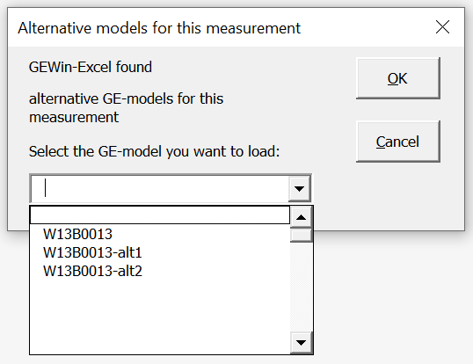
Figure 34

Be aware that the hyperlinked names are only placed when the outline map is created. When you have entered a new geo-electrical measurement and saved it to the GEWin-Excel database, the location will be visible on the outline map (if the entered measurement is located within focus of course), but NOT the hyperlinked name. To get GEWin-Excel to place the hyperlinked name with the measurement the outline map must be recreated. You can do this by:
- Deleting the sheet “OutlineMap” and then re-install the GEWin-Excel workbook. A new outline map will be created.
- Changing the focus of the outline map (see paragraph 4.4)

Zooming in

GEWin-Excel provides 2 ways to zoom in on the outline map; entering coordinates to define a new focus on the outline map or drawing a “zoom in”-window on the outline map.

Zooming in method 1:
After clicking on the button “Set new focus for the outline map” (see figure 1), a dialog will appear on which the limits of the outline map can be redefined (see figure 35).
Selecting the checkbox in the upper left corner of the dialog (“Set maximum focus”) will make the boxes for entering the coordinates inactive. After clicking the OK button, the focus of the outline map will be set to maximum.
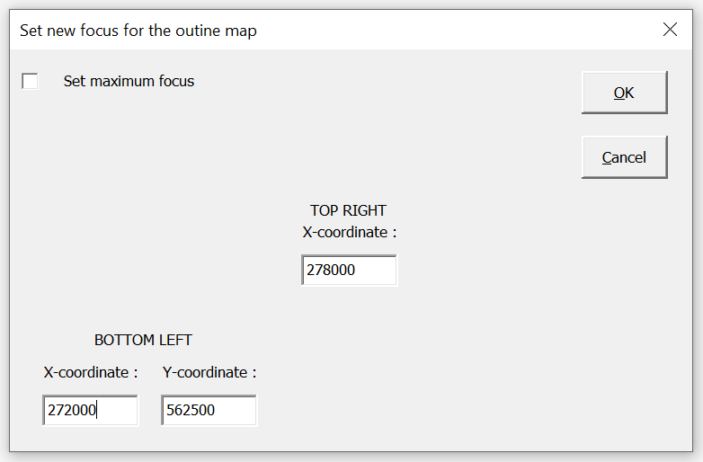
Figure 35

By entering new coordinates for the lower left corner and an x-coordinate to set the limit for the right-hand side of the outline map, a new focus for the outline map can be defined.

Zooming in method 2:
The alternative method to “zoom in”, works in 2 consecutive steps.
First click the “Draw zoom-in area”-button (see figure 1). Once you clicked this button, the cursor will change into a “hairline cross”. Now you can draw a rectangle on the outline map. The bottom left corner and the bottom right corner of the rectangle will define the new focus. If you made a mistake, simple select the drawn rectangle and press the <Delete>-button on your keyboard.
After you have drawn the rectangle on the outline map, you still must activate the zoom on the area. You do this by clicking on the “Activate zoom-in”-button (see figure 1).

Zooming out

GEWin-Excel stores the previous focuses on the outline map. You can go back to the previous focus by clicking on the “Zoom out”-button (see figure 1). After clicking on this “Zoom-out”-button, you will go 1 focus back. The focus that you are leaving will be lost.
You can Zoom-out until the base-focus. This base-focus equals the maximum focus. The maximum focus is defined by the minimum x-coordinate in the database minus 500m, the minimum y-coordinate in the database minus 500m and the maximum x-coordinate in the database plus 500m.

The X-section

Create a X-section

After clicking on the “Define X-section” button on the GEWin-Excel toolbar (see fig 1) a dialog will appear with the instructions for defining the cross section (see figure 36)
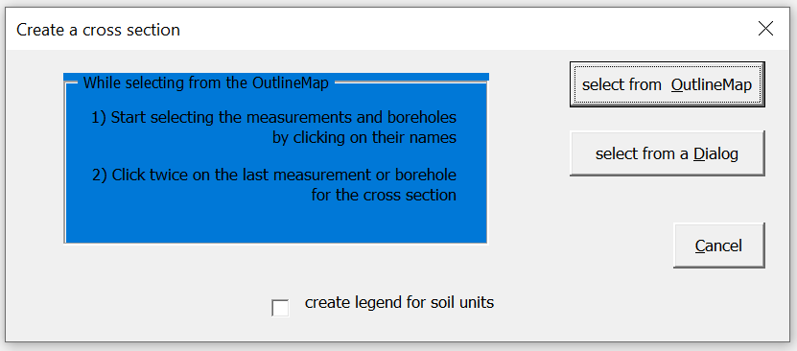
Figure 36

There are two alternatives available for creating a cross section:
- selecting the measurements and/or boreholes for the cross section from the interactive outline map (click the “select from OutlineMap”-button)
- selecting the measurements and/or boreholes for the cross-section from a dialog (click the “select from a Dialog”-button).

If you mark the checkbox in front of “create legend for soil units” at the bottom and click either the “select from OutlineMap”-button, or the “select from Dialog”-button, GEWin-Excel will create a legend instead of a cross section (see figure 39 in paragraph 5.2).

Ad 1)
After clicking on the “select from OutlineMap”-button, you can start selecting the boreholes and measurements that you want to place in the cross section. While moving the mouse indicator over the map, the mouse indicator will change to hand or an I-cursor (also called I-beam pointer) followed by a textbox with the name of the borehole or measurement, while shifting into the active field around the name. Boreholes and measurements that you want to place in the cross section, can easily be selected by clicking when the mouse indicator is in this active field around the name (so NOT on the blue dot of the borehole or the red cross in the centre of the measurement!). The trace of the cross section will be shown on the map by a green line (see figure 37).
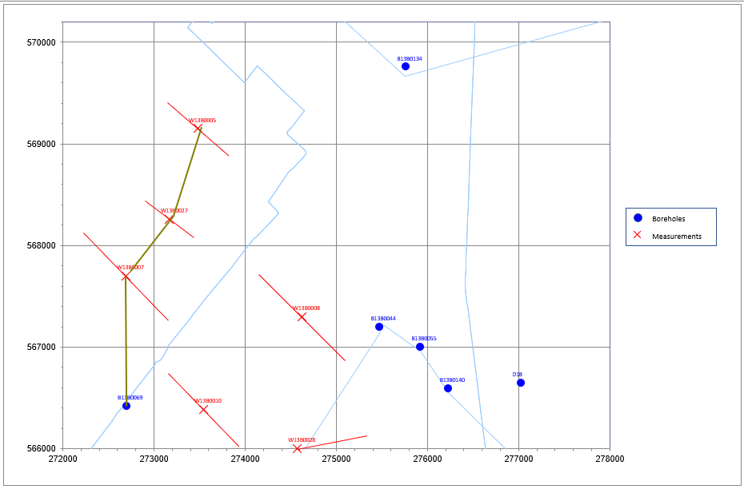
Figure 37

Clicking twice in the active field of the last measurement (or borehole) in the cross section will end the selection.
Immediately the cross section will be drawn on the “XSection” sheet. If this sheet is not yet present, it will be inserted.

Ad 2)
After clicking on the “select from a Dialog”-button, a dialog will appear from which you can select the measurements and/or boreholes for the cross section (see figure 38).
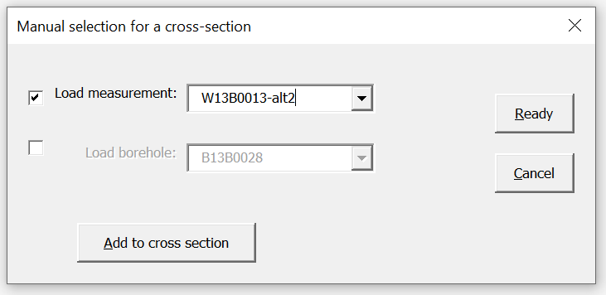
Figure 38

From the drop-down boxes the measurements and/or boreholes for the cross section can be selected from the GEWin-Excel database. Select the measurements and boreholes in sequence for the cross section. By marking the checkbox in front of either the drop-down box for the measurements or the boreholes, you can toggle between measurement and borehole.
After finding the desired measurement and/or borehole in the drop-down box, do NOT forget to click the “Add to cross section”-button, before selecting the next measurement and/or borehole.
The trace of the cross section will be drawn in the OutlineMap in a similar way as when you would have selected the item from the interactive OutlineMap (see figure 37).
After you have selected the last item for the cross section, click the “Ready”-button.
Immediately the cross section will be drawn on the “XSection” sheet. If this sheet is not yet present, it will be inserted.
Clicking on the “Cancel”-button will result in clearing the trace from the OutlineMap and quitting the dialog without change.

The “XSection” sheet

If the checkbox on the “Create a cross section” dialog form has been marked, GEWin-Excel will create a legend with the symbols that GEWin-Excel uses for the soil units in the borelogs (see figure 39).
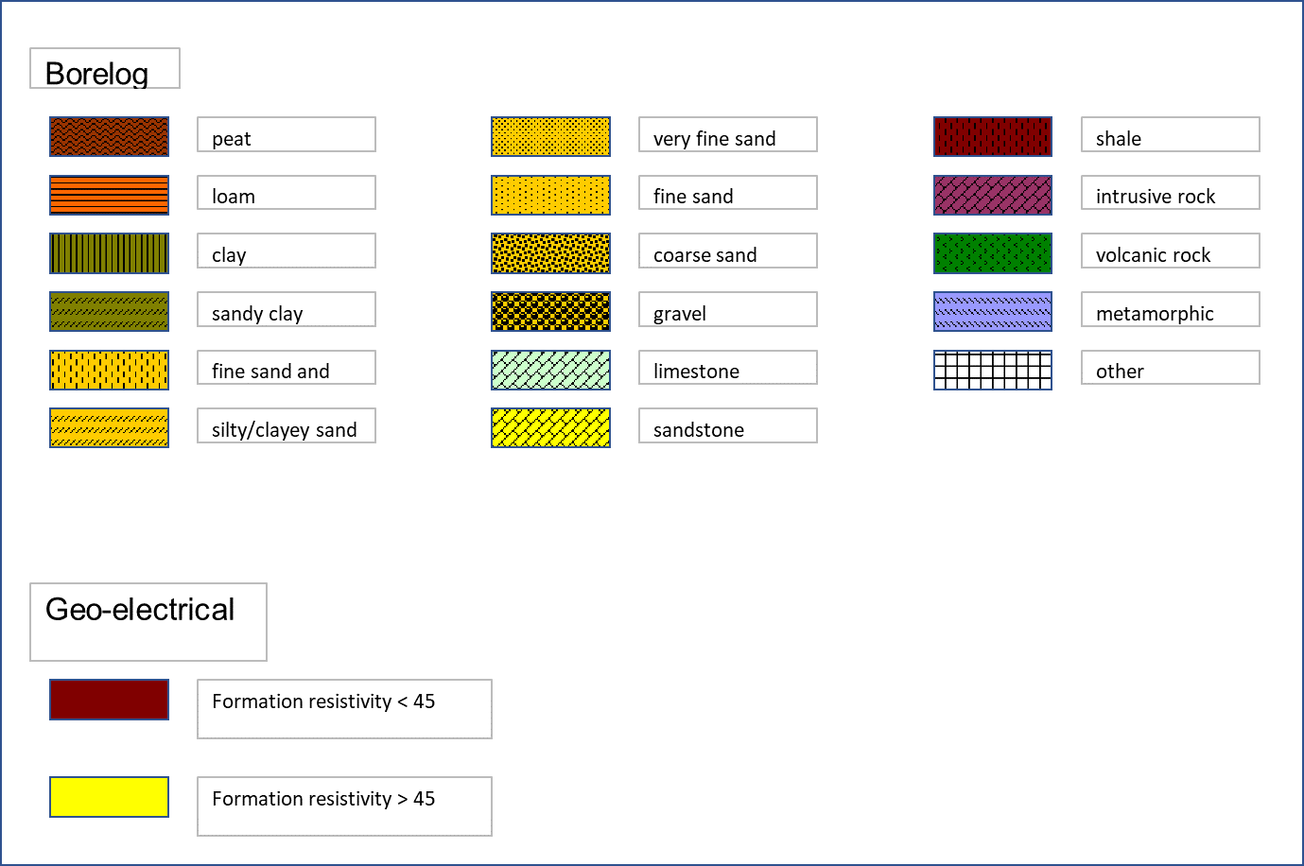
Figure 39

If the checkbox has not been marked, GEWin-Excel creates a cross section, immediately after clicking twice on the last borehole or measurement of the cross section. (see figure 40).

The names of the boreholes and measurements are placed on top of the logs. If the logs are located closely together, the names may be printed on top of each other. In that case it is possible to just manually shift the textboxes a little bit on the sheet. In other words, it is possible to post-process the cross-section sheet.
The logs are placed at a distance from each other, that corresponds with the distance between the measurements in the set trace.
Both the horizontal and vertical scales are set automatically is such a way that all the logs will fit optimally. If you have extended the last soil unit until a depth of 1000m-SL (i.e. the maximum depth scale of the “Borelog” graph) to visualize that this last soil unit is part of the geohydrological base (which often is close to the geo-electrical base) the vertical scale will be set such, that the geohydrological base will be printed with a thickness of at least 10m. Since the vertical scale also depends on the interpreted depth of the geo-electrical base in the geo-electrical logs, the printed thickness of this last soil unit can turn out to be much larger.
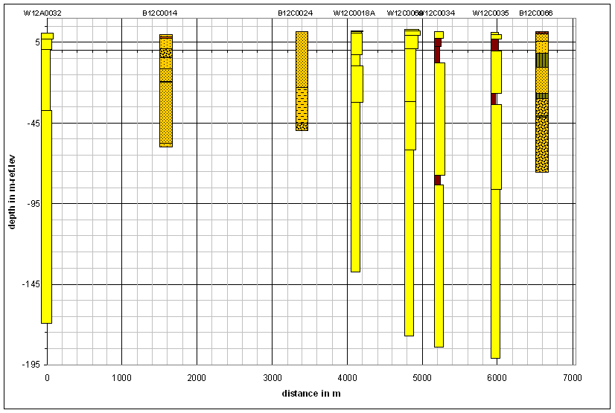
Figure 40

The soil units in the borelogs and the model layers of the GE-models are placed in the cross section, relative to the reference level and NOT relative to the surface level.
The cross section will present the borelogs with the same patterns and colours per soil unit as the borelogs on the “work” sheet. The geo-electrical measurements are presented as logs as well. The width of the bars indicating the model layers is logarithmic in a way that corresponds with the GE-model. If the formation resistivity of a model layer is less than 45Ωm, the bar that represents this model layer will have a dark red colour. If the formation resistivity is more than 45Ωm, the colour is yellow. A model layer with a formation resistivity of less than 45Ωm often represents a clay layer or layer with clayey sediments. By using these colours, it will be easier to quickly identify the location of clay layers in the cross section.

Using the standard Excel drawing tools, it is possible to manually connect clay and sand layers by adding “lines” or “free forms”.

